Installation Jenkins on Ubuntu

sudo apt-get update

sudo apt-get install openjdk-11-jdk -y

wget https://updates.jenkins.io/download/war/2.385/jenkins.war

sudo vi /lib/systemd/system/jenkins.service

sudo systemctl start jenkins.service

sudo systemctl enable jenkins.service

sudo systemctl status jenkins.service

[Unit]

Descrption=Manage Java service jenkins

[Service]

Environment="JAVA_HOME=/usr/lib/jvm/java-11-openjdk-amd64"

WorkingDirectory=/home/ubuntu

ExecStart=java -jar jenkins.war

Type=simple

Restart=on-failure

RestartSec=10

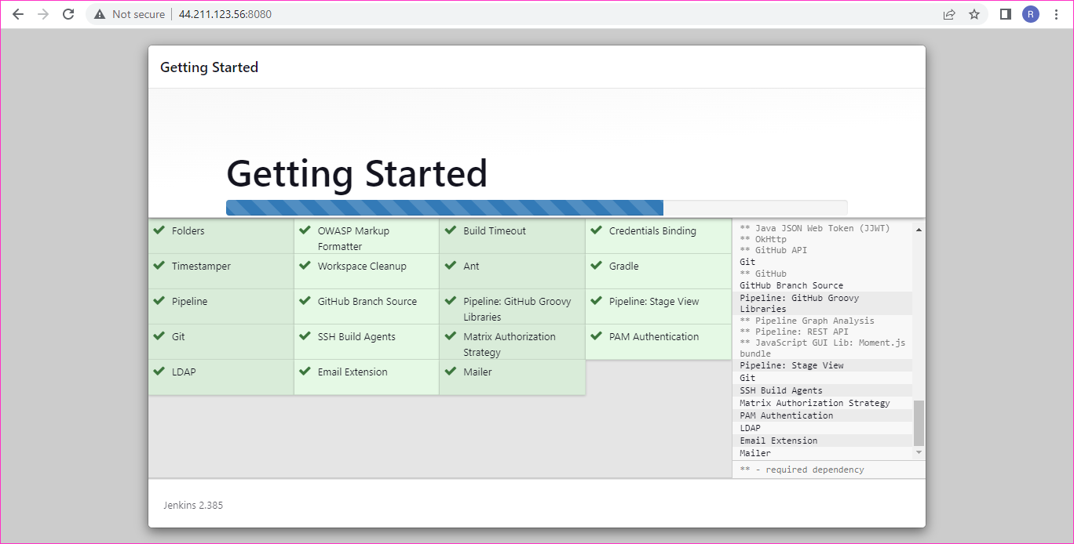

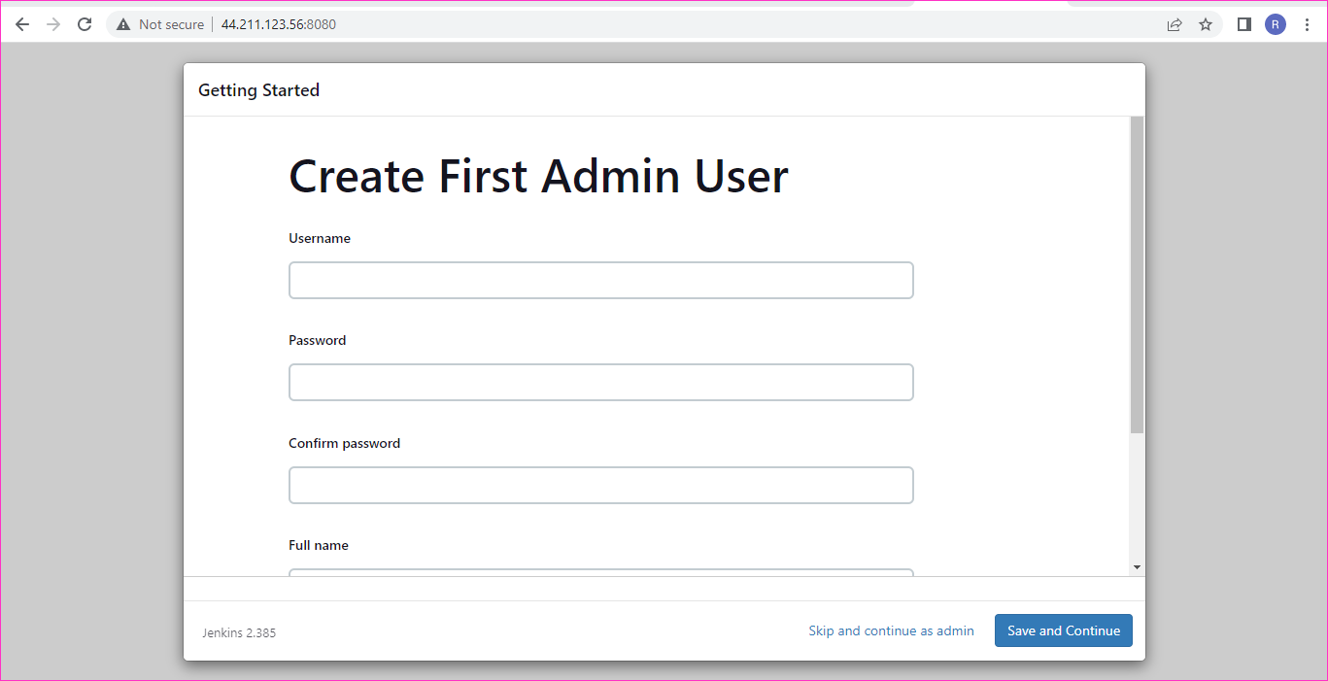

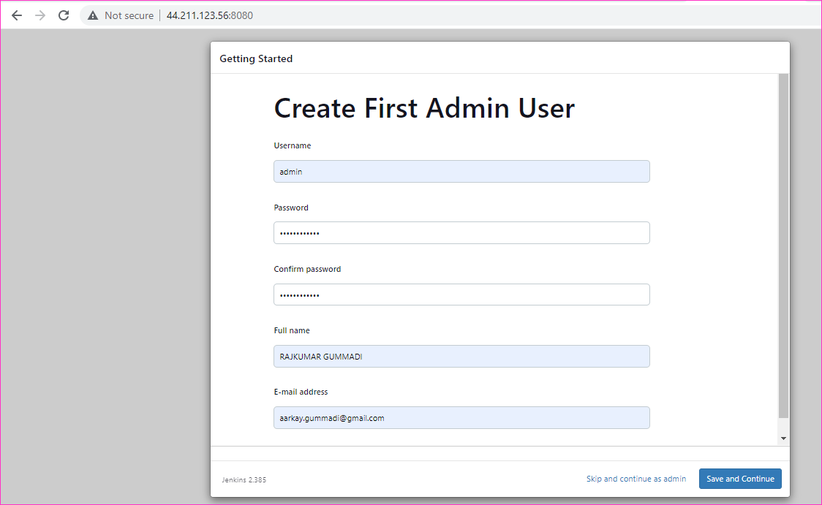

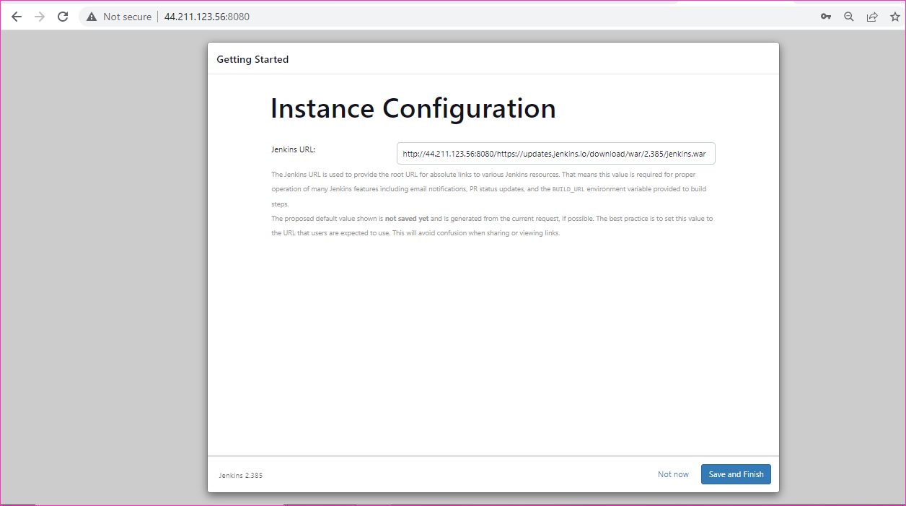

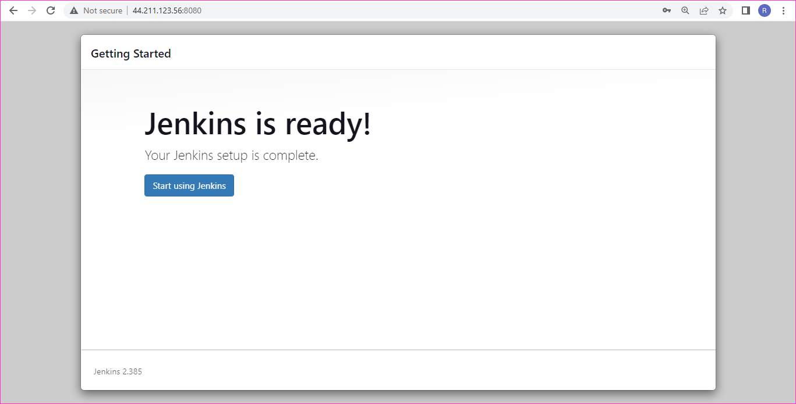

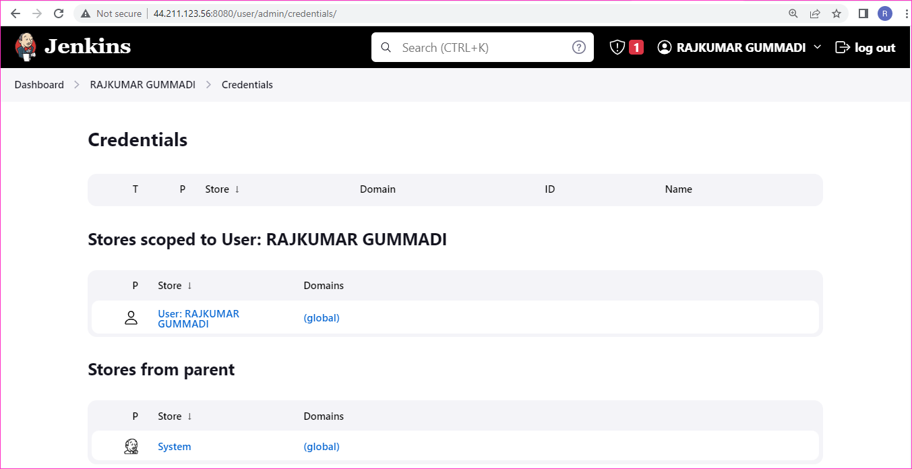

Playbook for the Jenkins installation on Ubuntu:20.04

--------------------------------------------------------------------------

